lab 6
Task 1
SELECT *
FROM flights
JOIN airline ON flights.airline_id = airline.airline_id
WHERE airline.airline_name = 'IPC';
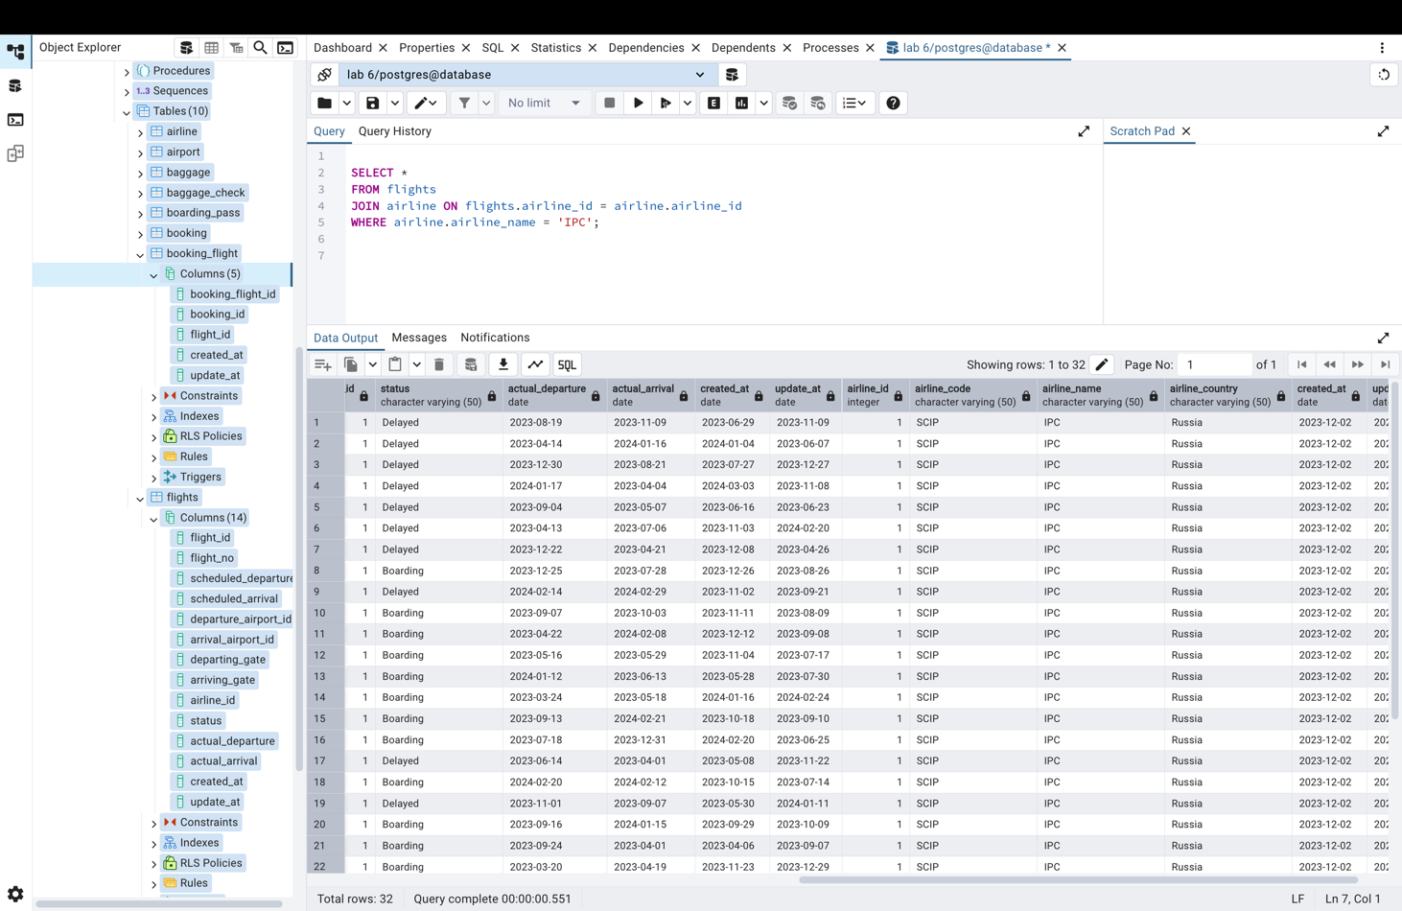

Task 2
SELECT flights.flight_id,
airline.airline_name,
airport.airport_name AS departure_airport
FROM flights
JOIN airline ON flights.airline_id = airline.airline_id
JOIN airport ON flights.departure_airport_id = airport.airport_id;

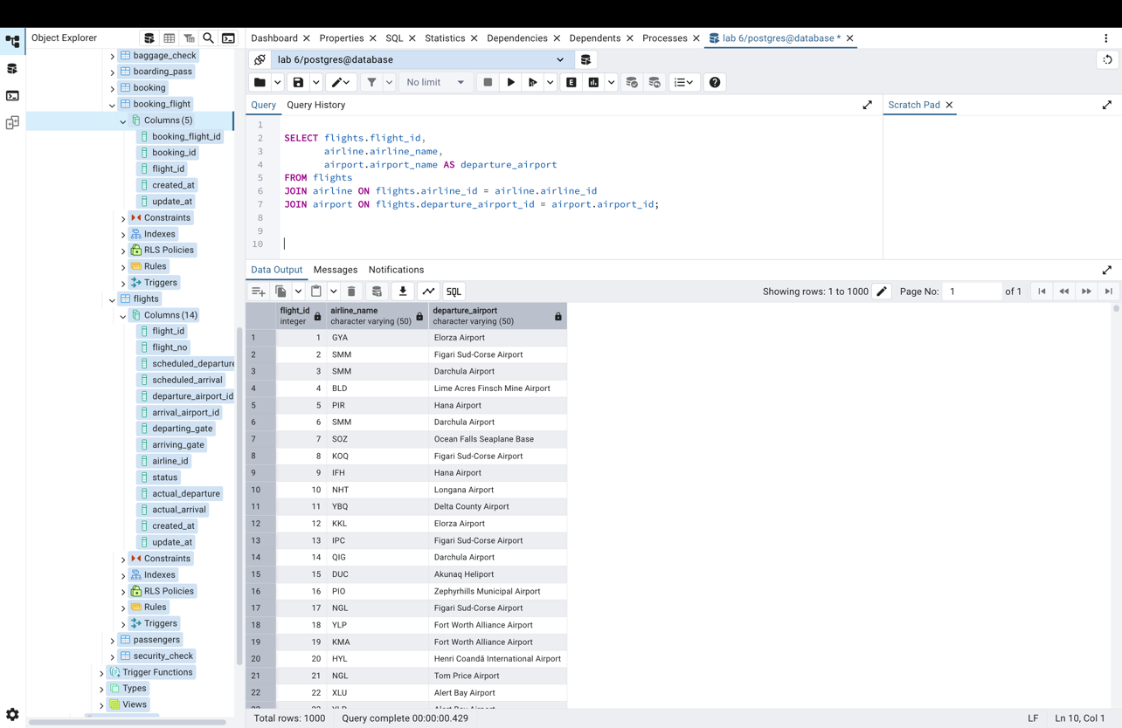

Task 3
SELECT a.airline_name
FROM airline a
LEFT JOIN flights f ON a.airline_id = f.airline_id
AND f.scheduled_departure BETWEEN CURRENT_DATE
AND (CURRENT_DATE + INTERVAL '1 month')
WHERE f.flight_id IS NULL;
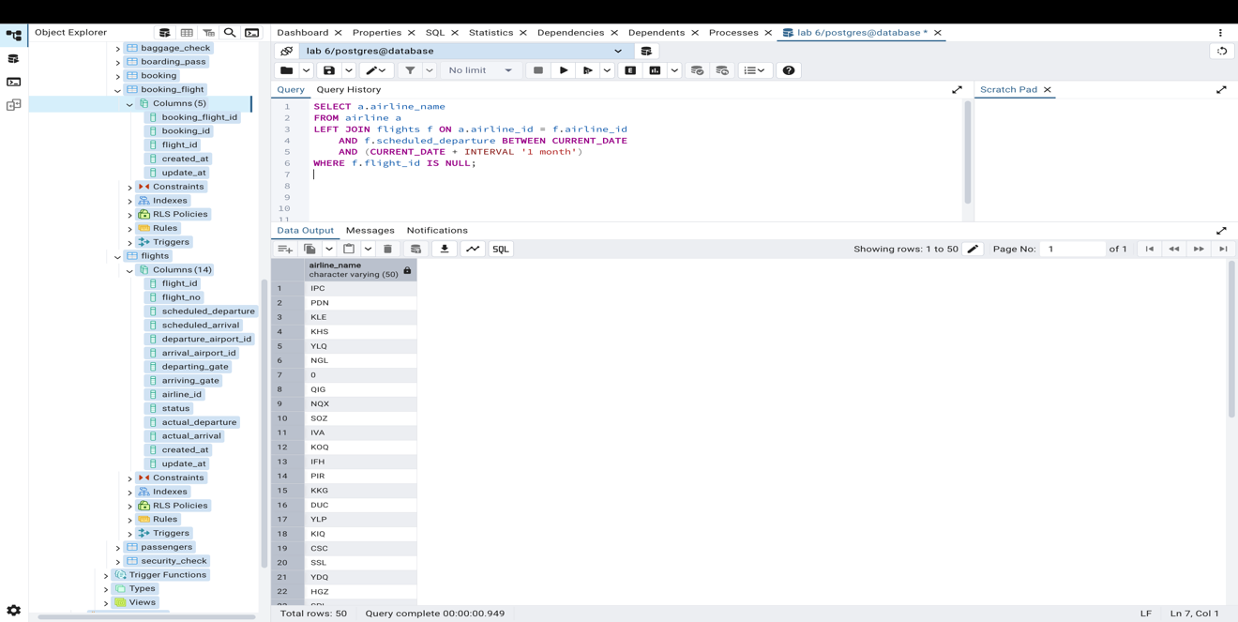
Task 4
SELECT p.first_name, p.last_name, p.passport_number
FROM passengers p
JOIN booking b ON p.passenger_id = b.passenger_id
JOIN booking_flight bf ON b.booking_id = bf.booking_id
JOIN flights f ON bf.flight_id = f.flight_id
WHERE f.flight_id = 20;
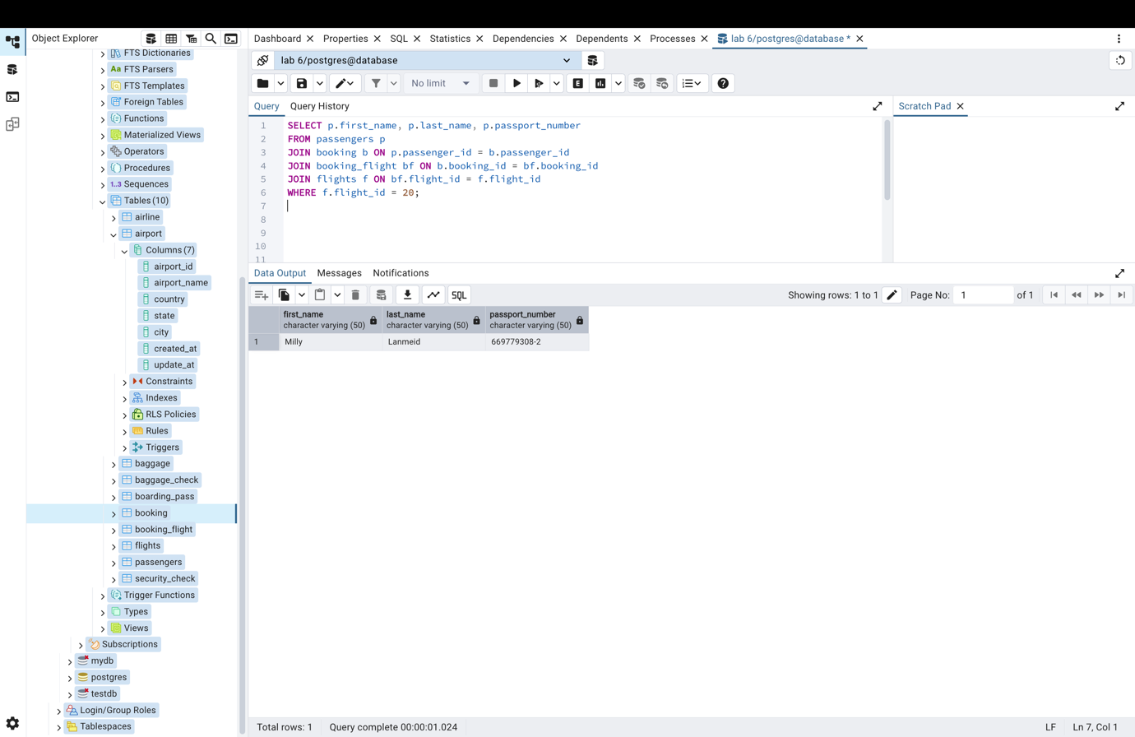
Task 5
SELECT f.flight_id,
AVG(b.price) AS average_price,
SUM(b.price) AS total_price,
MAX(b.price) AS highest_price,
MIN(b.price) AS lowest_price
FROM flights f
JOIN booking b ON f.flight_id = b.passenger_id
GROUP BY f.flight_id;
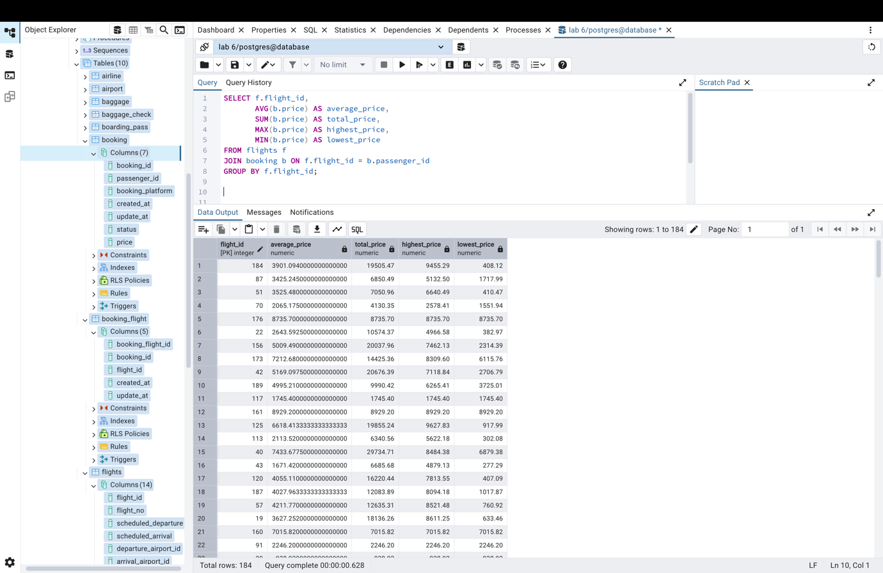

Task 6
SELECT f.flight_id,
a.airline_name,
dep.airport_name AS departure_airport,
arr.airport_name AS arrival_airport
FROM Flights f
JOIN Airline a ON f.airline_id = a.airline_id
JOIN Airport dep ON f.departure_airport_id = dep.airport_id
JOIN Airport arr ON f.arrival_airport_id = arr.airport_id
WHERE arr.country = 'China';
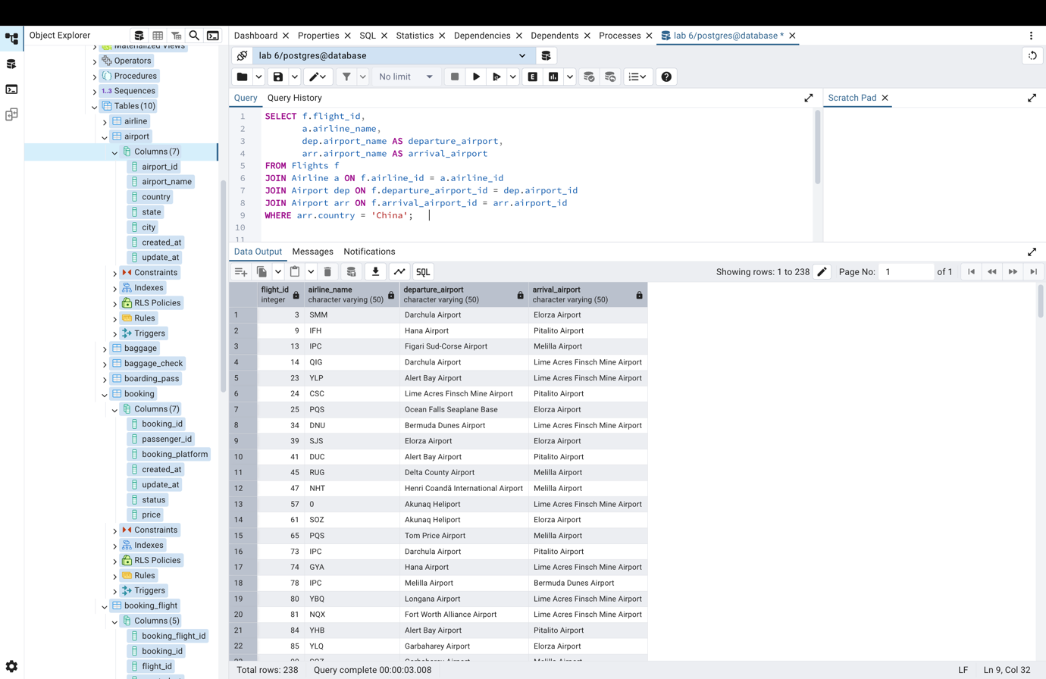
Task 7
SELECT p.first_name, p.last_name,
a.airport_name AS arrival_airport
FROM passengers p
JOIN booking b ON p.passenger_id = b.passenger_id
JOIN booking_flight bf ON b.booking_id = bf.booking_id
JOIN flights f ON bf.flight_id = f.flight_id
JOIN airport a ON f.arrival_airport_id = a.airport_id
WHERE AGE(CURRENT_DATE, p.date_of_birth) < INTERVAL '18 years';
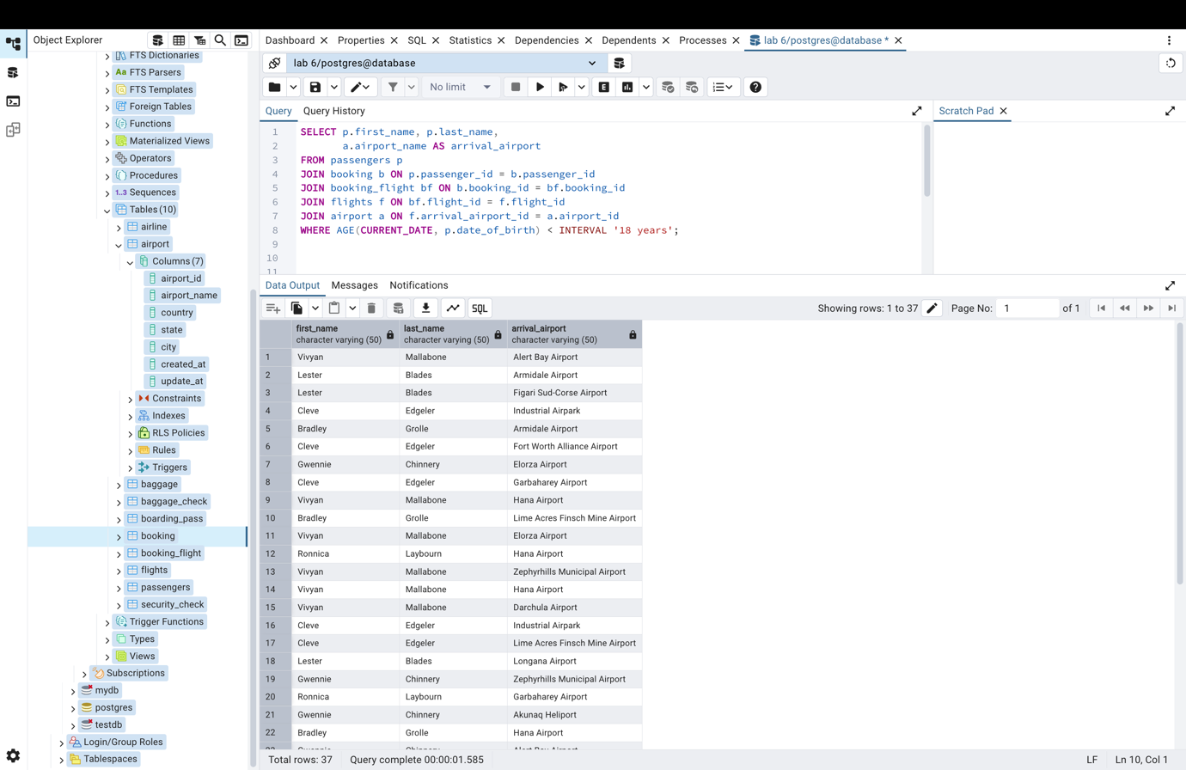

Task 8
SELECT p.first_name || ' ' || p.last_name AS full_name,
p.passport_number,
f.scheduled_arrival AS arrival_time
FROM passengers p
JOIN booking b ON p.passenger_id = b.passenger_id
JOIN booking_flight bf ON b.booking_id = bf.booking_id
JOIN flights f ON bf.flight_id = f.flight_id;
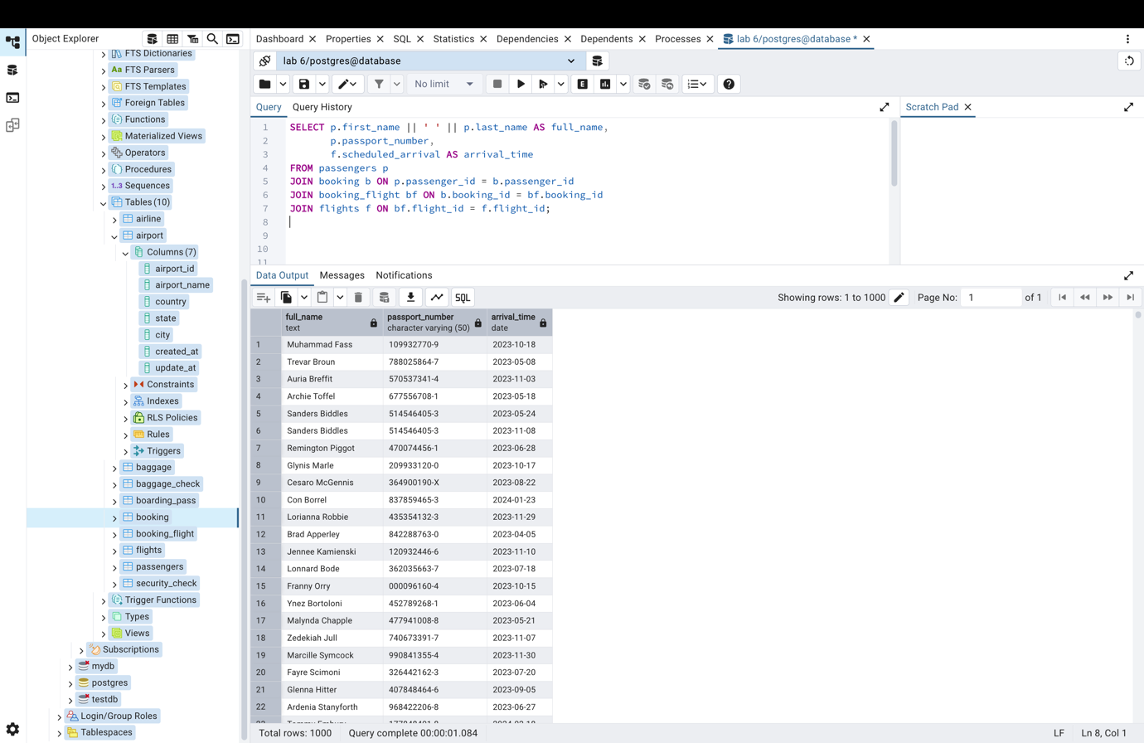

Task 9
SELECT a.country AS airport_country,
f.flight_id,
ar.airline_name
FROM flights f
JOIN airline ar ON f.airline_id = ar.airline_id
JOIN airport a ON f.departure_airport_id = a.airport_id
WHERE ar.airline_country = a.country
GROUP BY a.country, f.flight_id, ar.airline_name;
